
UT/IPH/1223/A 30-OCT-2023
UNIT TEST (2023-24)
Subject: Informatics Practices(H)  Grade: XII |  | Max. Marks: 50  Time: 2 ½ Hrs
 | SECTION A |  |  | (10)
1. | An organization purchase new computers every year and dumps the old one into the local dumping yard. Write the name of the most appropriate category of waste that the organization is creating every year, out of the following options: |  |  | 1
 | - Business waste |  | - Commercial waste
 | - E-waste |  | - Green Waste
2. | A computer network created by connecting the computers of your school’s computer lab is an example of |  |  | 1
 | - LAN |  | - MAN
 | - WAN |  | - PAN
3. | Legal term to describe the right of creator of original creative or artistic work is called__________. |  |  | 1
 | - Copyright |  | - Copyleft
 | - GPL |  | - Trademark
4. | Which of the following statement is wrong in context of DataFrame? |  |  | 1
 | - Two dimensional, size is Mutable
 | - Can perform Arithmetic operators on rows and columns.
 | - Homogeneous tabular data structure
 | - Create Dataframe from numpy ndarray
5. | Unsolicited commercial emails is known as …………..? |  |  | 1
 | - spam |  | - virus
 | - malware |  | - worm
6. | Which protocol allow us to have voice calls over the internet? |  |  | 1
 | - HTTP |  | - VoIP
 | - Video Chat |  | - SMTP
7. | Stealing someone else’s intellectual work and representing it as own is called ____________ . |  |  | 1
 | - Identity theft |  | - Plagiarism
 | - Phishing |  | - Pharming
8. | Which of the following library should be imported for creating chart in python. |  |  | 1
 | - pandas |  | - math
 | - matplotlib |  | - random
9. | _____________________ function is used to display chart. |  |  | 1
 | - showing( ) |  | - show( )
 | - display( ) |  | - screen( )
10. | Assertion (A): DataFrame has both a row and column index.  Reasoning (R): .loc() is a label based data selecting method to select a specific row(s) or column(s) which we want to select.
 | - Both A and R are true and R is the correct explanation for A
 | - Both A and R are true and R is not the correct explanation for A
 | - A is True but R is False
 | - A is false but R is True
 | SECTION B |  |  | (12)
11. | What will be the output of the following python program  import pandas as pd  d1={'Name':['sapna','anmol','rishul','sameep'],  'Agg':[56,67,75,76], 'Age':[16,10,16,19]}  df=pd.DataFrame(d1)  print(df) |  |  | 2
12. | What is IPR? Why should it be protected? |  |  | 2
13. | Explain the terms Static and dynamic Web pages. |  |  | 2
14. | Carefully observe the following code:  import pandas as pd  D1={'S1': 'India', 'S2': 'Russia', 'S3': 'World'} D2={'School': 'EOIS', 'Place': 'Moscow'} data={1:D1,2:D2} df=pd.DataFrame(data)  print(df)  Answer the following  - List the index of the DataFrame df  - i. List the column names of DataFrame df |  |  | 2
15. | Write a python code to create a DataFrame with appropriate column headings from the list given below: [[201,’Gurmeet’,95],[202,’Praveen’,89],[203,’Suman’,97],[204.’Yogesh’,91] |  |  | 2
16. | Write some of the health issues caused due to technology. |  |  | 2
17. | Data about colleges in Delhi University, number of courses they run for science, commerce and humanities are stored in a CSV file(DU.csv). Present it using a bar graph. |  |  | 2
 | SECTION C |  |  | 12
18. | 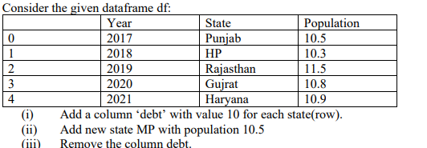 |  |  | 3
19. | What do you understand by Net Etiquettes? Explain any two such etiquettes. |  |  | 3
20 | Write any 2 differences between Star and Bus topology? |  |  | 3
21. | Distinguish between LAN and WAN. |  |  | 3
 | SECTION D |  |  | (14)
22. | i) Mr. Summit, a data analyst has designed the DataFrame df that contains data about Computer infrastructure with ‘S01’, ‘S02’, ‘S03’, ‘S04’, ‘S05, ‘S06’ as indexes shown below. Answer the following questions:  a) df.shape  b) df[2:4]  ii) Write Python statement to display the data of working column of indexes S03 to S05.  iii) Write Python statement to compute and display the difference of data of computers column and working column of the above given DataFrame. |  |  | 4
23. | Observe the following figure. Write the python program for obtaining this as output. . Also give suitable python statement to save this chart  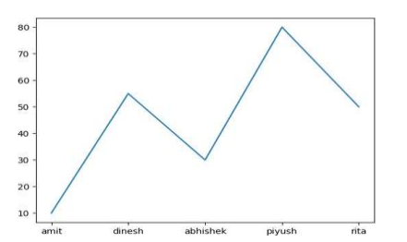 |  |  | 5
24. | 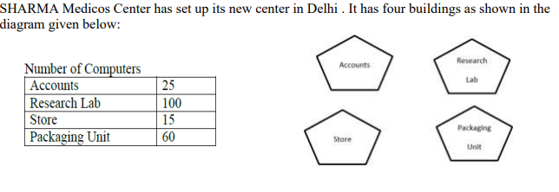  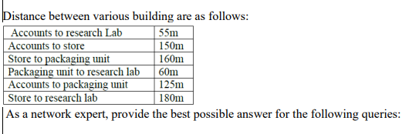  As a network expert, provide the best possible answer for the following queries:  - Suggest a cable layout of connections between the buidings  - Suggest the most suitable place (i.e building) to house the server of this organization.  - Suggest the placement of following devices with justification:  - Repeater b) Hub/Switch  - Suggest a system(hardware/softeware) to prevent unauthorised access to or from the network  - The company is planning to link its head office situated in Delhi with the offices in hilly areas.Suggest a way to connect it economically. |  |  | 5
***

